**Name – Ankesh Mobar**

Lab 1.

**Exp 1. WAP Hello world.**

Coding

//Hello world//

#include<stdio.h>

int main(){

    printf("hello world");

    return 0;

}

Output

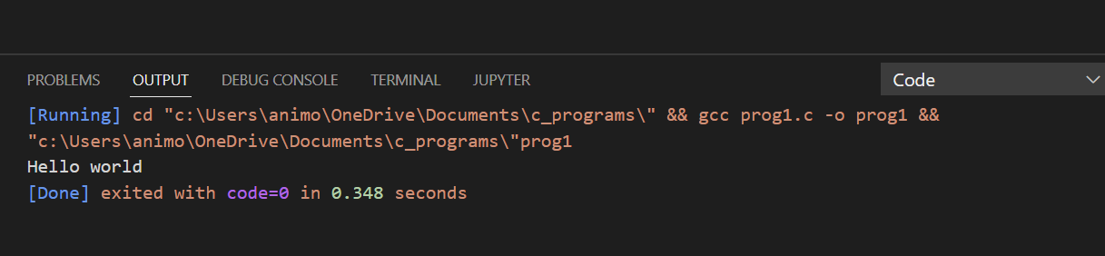

**Exp 2. WAP Name, address, qualification**

Coding

//Name,Address, Qualification//

#include<stdio.h>

int main(){

    printf("Name - Ankesh Mobar\n");

    printf("Address : Sainik Colony Dehradun\n ");

    printf("Qualification:BSC Passout ");

    return 0;

}

Output 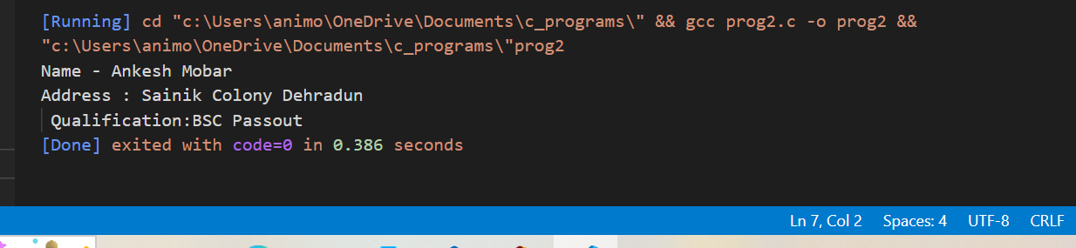

**Exp 3. WAP Add two numbers**

Coding

//Add two number//

#include<stdio.h>

int main(){

    int num1;

    int num2;

    int num3;

    num1=10;

    num2=20;

    num3=num1+num2;

    printf("num3=%d",num3);

    return 0;

}

Output

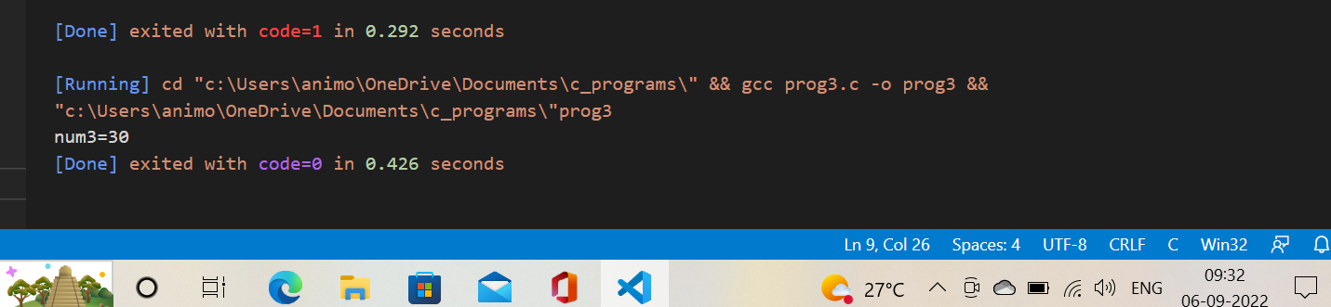

**Exp 4. WAP take input from user & add two numbers.**

Coding

//Take input from user & add two nos.//

#include<stdio.h>

int main(){

    int a,b,sum;

    printf("Enter First number\n");

    scanf("%d",&a);

    printf("Enter second number\n");

    scanf("%d",&b);

    sum=a+b;

    printf("%d",sum);

    return 0;

}

Output

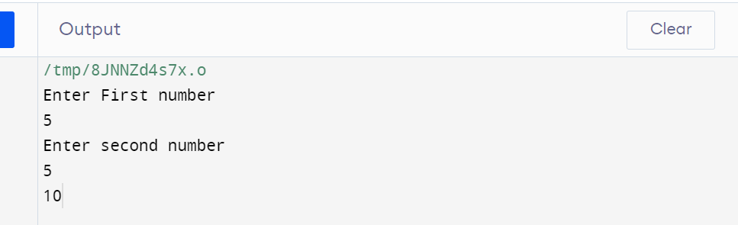

**Exp 5. Distance between two cities in km. Print the distance in meter, feet, inches & centimeter.**

Coding

// Distance between two cities in KM//

#include <stdio.h>

int main() {

float kilometer, centimeter , inches, meter, feet;

printf("Enter the distance between two cities in km=");

scanf("%f",&kilometer);

meter=1000*kilometer;

feet=3280.84*kilometer;

inches=39370.1*kilometer;

centimeter=10000*kilometer;

printf("distance between two cities in meter=%fm\n",meter);

printf("distance between two cities in feet=%ff\n",feet);

printf("distance between two cities in meter=%fin\n",inches);

printf("distance between two cities in meter=%fcm\n",centimeter);

return 0;

}

Output

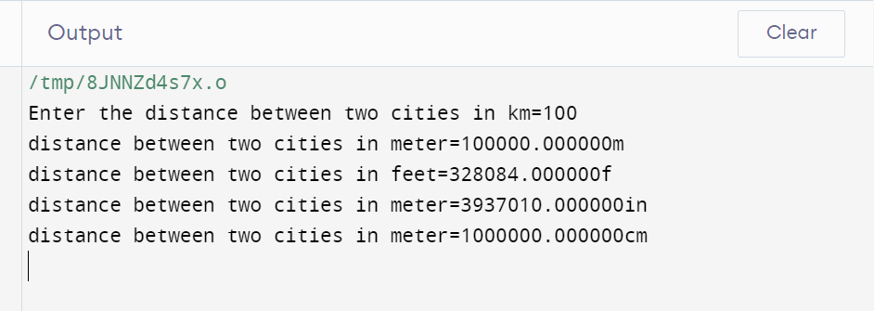

**Exp 6. Take input from user for radius and side of square WAP to print perimeter and circumference.**

Coding

// Perimeter and circumference//

#include <stdio.h>

int main() {

    float circle_circumference, square_perimeter, cir_rad, sq_side;

    printf("please enter the side of square in cm= ");

    scanf("%f", &sq_side);

    printf("please enter the radius of circle in cm= ");

    scanf("%f",&cir_rad);

    circle_circumference=2*3.14*cir_rad;

    square_perimeter=4* sq_side;

    printf("circumference of circle is =%.2f cm\n",circle_circumference);

    printf("perimeter of square is =%.2f cm", square_perimeter);

    return 0;

}

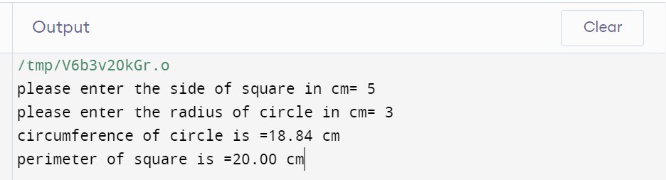

**Exp 7. Paper of size A0 has dimension 1184mm*841mm. Each subsequent size A(n) is defined as A(n-1) cut in parallel to its shorter side. Thus paper of size A1 would have dimension 841mm*594mm WAP to calculate & print paper sizes A0,A1,A3…………..A8.**

Coding

// Find the size of paper//

#include <stdio.h>

int main() {

    int i, height= 1189, width= 841;

    printf("Size of A0 paper %dmm * %dmm\n",height,width);

    printf("Size of A1 paper %dmm * %dmm\n",width, height/2);

    printf("Size of A2 paper %dmm * %dmm\n",height/2,width/2);

    printf("Size of A3 paper %dmm * %dmm\n",width/2,height/4);

    printf("Size of A4 paper %dmm * %dmm\n",height/6,width/4);

    printf("Size of A5 paper %dmm * %dmm\n",width/4, height/8);

    printf("Size of A6 paper %dmm * %dmm\n",height/8,width/8);

    printf("Size of A7 paper %dmm * %dmm\n",width/8, height/16);

    printf("Size of A8 paper %dmm * %dmm\n",height/16,width/16);

    return 0;

}

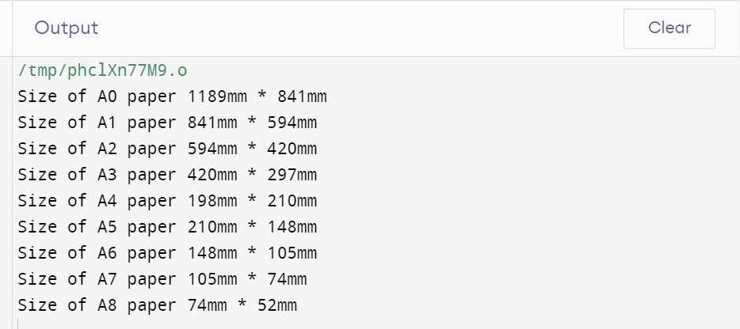

**Exp8. Print the address of a variable.**

// Find the address of a variable//

#include <stdio.h>

int main() {

    char a;

    printf("Address of variable = %p", &a);

    return 0;

}

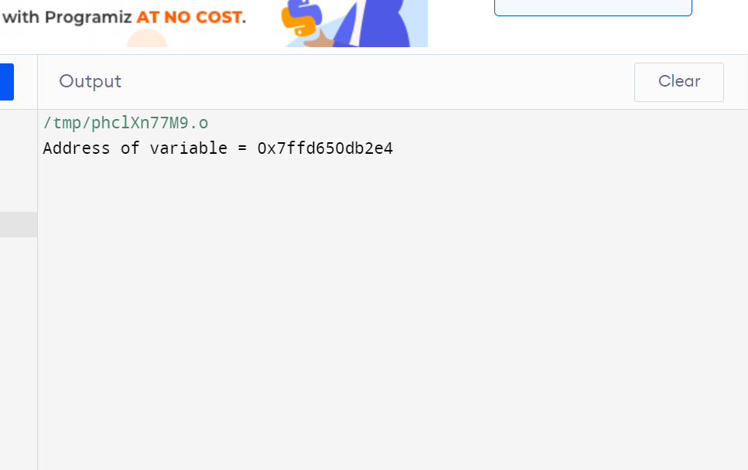

**Exp9. Take a character input from user & print its ASCII Value.**

Coding

// Show the ASCII value of character//

#include <stdio.h>

int main() {

    char c;

    printf("Please enter the character = ");

    scanf("%c",&c);

    printf("ASCII value of %c = %d",c,c);

    return 0;

}

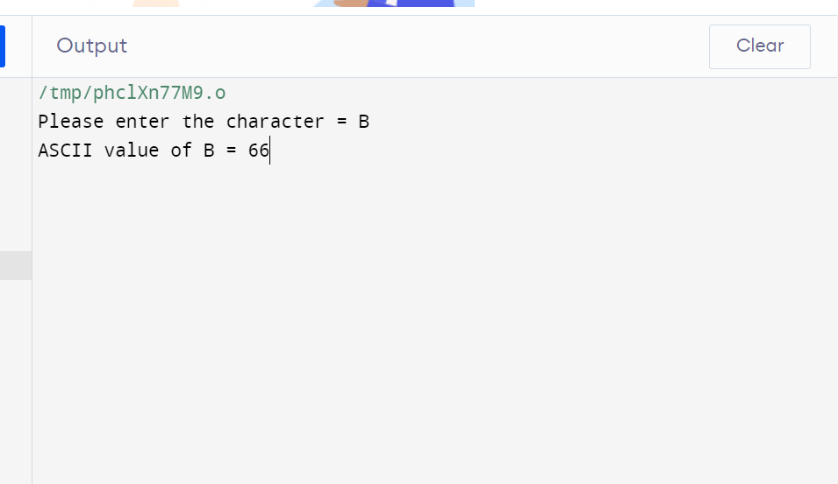

**Exp10. WAP to reverse the number , take input from user .**

Coding

// Take input from user WAP to reverse the  number.

#include <stdio.h>

int main() {

    int num,rev=0;

    printf("\nEnter the number to get reverse of it:");

    scanf("%d",&num);

    while(num>0){

        rev=(rev*10)+(num%10);

        num=num/10;

    }

printf("\nThe reverse of the entered is : %d\n\n",rev);

    return 0;

}

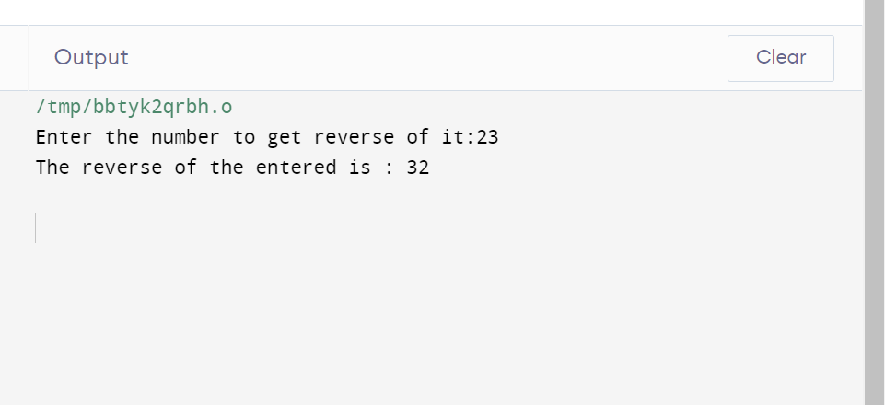

**Exp11. WAP to add the digits of a five digit number.**

Coding

// WAP to Add the digits of a five-digit number.

#include <stdio.h>

int main() {

    int num, sum=0;

    printf("\nEnter any number to get the sum of the digit: ");

    scanf("%d",&num);

    while(num>0){

        sum+=num%10;

        num/=10;

    }

    printf("\nThe sum of all the digits that you have entered is:%d\n\n",sum);

    return 0;

}

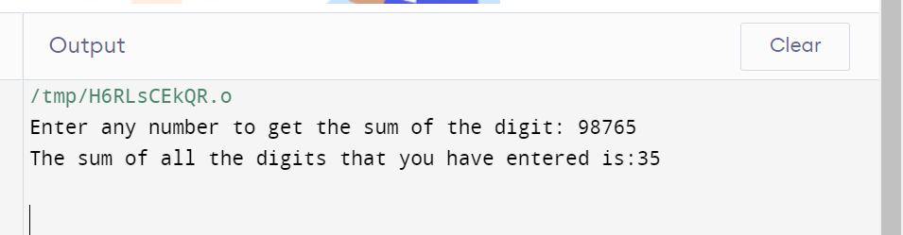

**Exp12. Consider a currency system in which there are notes of seven denominations, namely Rs1, Rs2, Rs5, Rs10, Rs20, Rs50, Rs100. If a sum of Rs N is entered through keyboard, write a program to compute the smallest number of notes that will combine to give Rs N. (While Demonstrating output, give two set of inputs).**

Coding

// Currency system//

#include <stdio.h>

int main() {

    int amount;

    int rs100=0, rs50=0, rs20=0, rs10=0, rs5=0, rs2=0, rs1=0;

    printf("\nEnter the amount to get the denominations: ");

    scanf("%d",&amount);

    rs100=amount/100;

    amount%=100;

    rs50=amount/50;

    amount%=50;

    rs20=amount/20;

    amount%=20;

    rs10=amount/10;

    amount%=10;

    rs5=amount/5;

    amount%=5;

    rs2=amount/2;

    amount%=2;

    rs1=amount/1;

    amount%=1;

    printf("\nNumber of notes of Rs 100\t:%d\nNumber of notes of Rs 50\t:%d\nNumber of notes of Rs 20\t:%d\nNumber of notes of Rs10\t:%d\nNumber of coins of Rs 5\t:%d\nNumber of coins of Rs2\t:%d\nNumber of coins of Rs1\t:%d\n\n",rs100,rs50,rs20,rs10,rs5,rs2,rs1);

    return 0;

}

